|  |  |
| --- | --- |
| Date | 15 October 2022 |
| Team ID | PNT2022TMID36188 |
| Project Name | IOT based Smart Crop Protection System for Agriculture |
| Maximum Marks | 4 Marks |

# 

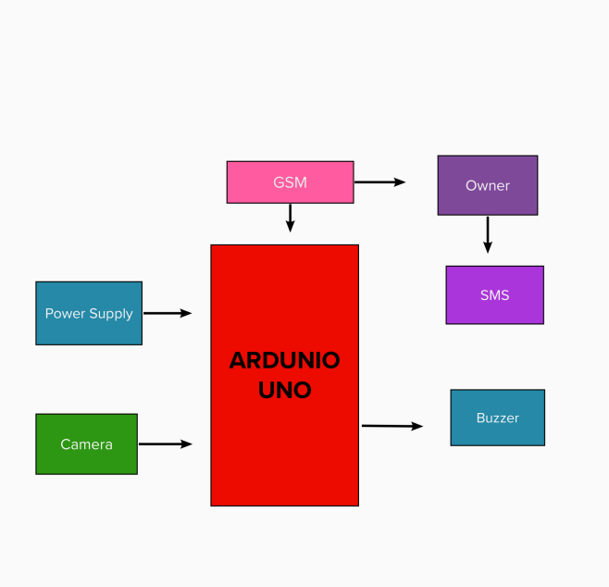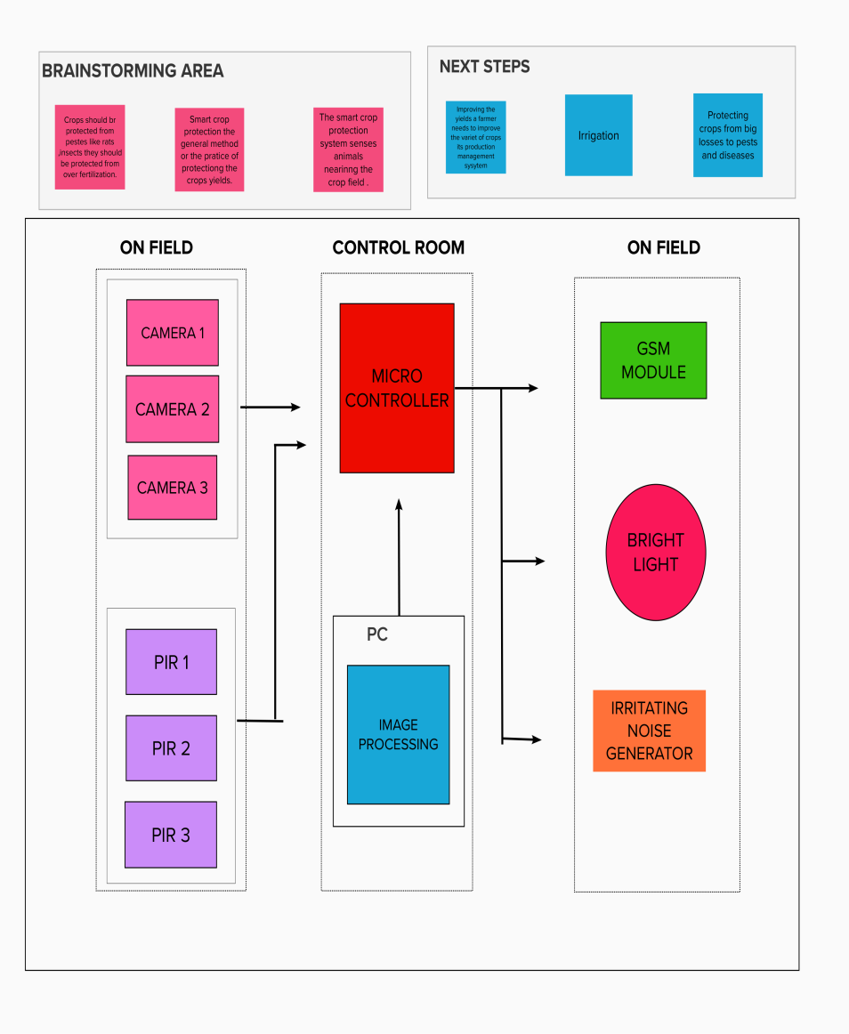**DATA FLOW DIAGRAM:**

**Simpliﬁed Diagram:**

* This is an Arduino Uno based framework utilizing microcontroller.
* This framework utilizes a PIR sensor to identify intruders close to the ﬁeld and additional to it a temperature and humidity sensor to maintain a soil moisture.
* When animal and birds approach close to the PIR(passive infrared Sensor), it detects the movement birds or animals
* After getting the initial input signal from the warm body, it is passed for further processing, then it will be passed one to the microcontroller.
* Then the system will be activated, immediately the buzzer goes on and simultaneously it sends a SMS to the user.
* Microcontroller (Arduino Uno) is used for reading the inputs from PIR .
* The temperature sensor used to maintain a moisture of soil,it can help to maintain a water quantity in land.
* The GSM module is used for sending SMS to user.

# User Stories:

|  |  |  |  |  |  |  |
| --- | --- | --- | --- | --- | --- | --- |
| **User type** | **Functional Requirement** | **User Story Number** | **User Story / Task** | **Acceptance criteria** | **Priority** | **Release** |
| User | Data collecting | USN-1 | Smart farming based IOT | Sensing of Agriculture data and storing. | High | Sprint-4 |
|  |  | USN-2 | As an user, I will inform the farmer to protect the crops. | I can inform the farmer. | Medium | Sprint-2 |
|  |  | USN-3 | Extract data from source. | Management of data through expert and investigation method | High | Sprint-2 |
| User 2 | Login | USN-4 | As an co-user, I can send the alert message to the farmers. | I can alert farmers. | High | Sprint-1 |
| Farmer | Login | USN-5 | As a farmer, I will follow the route to the crop which can avoid are detect animal intrusion. | I can reach the crops. | High | Sprint-2 |
| Crop Protector |  | USN-6 | A an crop protector. | In can protect the crop. | Medium | Sprint-2 |
| Farmer | Login | USN-7 | As a supervisior,I can  Supervise the crop and ensure the hygiene process. | I can manage all these process going good. | High | Spirit-1 |
| Crop yielder | Register | USN-8 | As a crop yielder,I can yield more crop. | I can register smart crop. | Medium | Spirit-3 |
| Crop Monitor |  | USN-9 | As a crop monitor,I  check the quality of IIOTdevice's quality. | I can check the IOT device. | Medium | Spirit-3 |